ICS330 – Assignment 1: Site-to-Site IPsec VPN for Horizon Enterprises

202412507 - Alyazai Zayed Almansoori
Instructor:
Date:

Introduction
Located in New York, Horizon Enterprises is a multinational corporation that needs a secure communication between its offices which are located in different locations. In this assignment, we are going to implement the required network on the identified sites: Dubai, London and Paris. This network will be designed using Cisco Packet Tracer with an objective of build the routed network, configure a full-mesh set of Site-to-Site IPsec VPN tunnels, test connectivity, troubleshoot problems, and verify that traffic was being encrypted.
Part 1: Understanding Site-to-Site IPsec VPNs
Advantages and disadvantages
Two major advantages of using VPNs are confidentiality and cost efficiency. IPsec protects information travelling across an untrusted public network by providing security services such as confidentiality, integrity, peer authentication, and replay protection. This is important for Horizon Enterprises as business information should not be subjected to any parties that can see Internet traffic travelling between offices. As described by Barker et al. (2020), IPsec is a network-layer security framework that can be used to secure communications across an IP network. Another advantage is that businesses can take advantage of current Internet connections instead of leasing dedicated private circuits between all offices. A VPN can thus ensure secure connectivity and utilize the existing network infrastructure.
However, there are drawbacks as well. VPN performance depends on the Internet connection; hence, when offices are experiencing poor communication quality, it can be due to congestion, latency, packet loss, or an outage with the Internet service provider. Secondly, as the number of sites grows, the complexity of deployment and maintenance of VPN also becomes complicated. For instance, for a full-mesh with 3 offices, there will be 3 logical tunnels to create, and each router will need a set of correctly matched peers, encryption settings, authentication parameters and interesting-traffic rules. If the setting is incorrect, it can result in not establishing the tunnel or in having an intermittent connection.
Definition and relevance
Site-to-Site IPsec VPN is a virtual private network (VPN) connection between networks that passes through an untrusted network (typically the Internet) and are secured with IPsec security mechanisms. Unlike a remote-access VPN, which commonly connects an individual user to a corporate network, a site-to-site VPN connects entire networks through security gateways such as routers or firewalls. In this assignment, DXB-R1, LON-R1, and PAR-R1 act as the VPN endpoints. Traffic from 10.15.1.0/24 to 10.25.2.0/24, for example, is identified as interesting traffic and protected between the Dubai and London routers.
The full-mesh design provides a direct protected relationship between every pair of offices: Dubai-London, Dubai-Paris, and London-Paris.
IPsec phases
The implementation used IKEv1 with an ISAKMP policy for Phase 1 and an IPsec transform set for Phase 2. In IKE Phase 1, the peers negotiate parameters for an IKE security association and authenticate one another. The practical configuration used AES-256 encryption, SHA hashing, pre-shared-key authentication, and Diffie-Hellman group 5. The shared key was configured consistently for each remote peer.
IKE Phase 2 establishes IPsec security associations for the actual protected data. In the practical topology, the transform set was named VPN-SET and used ESP with AES encryption and SHA-HMAC integrity/authentication. The crypto ACLs identify which source and destination networks must be protected. Cisco documentation explains that a transform set defines the combination of IPsec security protocols and algorithms negotiated by the peers, while crypto ACLs identify the traffic to protect. Once the appropriate security associations exist, matching packets are encapsulated and encrypted before crossing the public network and decrypted at the receiving VPN endpoint.
Encryption and authentication algorithms
For a multinational corporation, strong modern algorithms should be preferred. AES is an established symmetric encryption standard and AES-256 provides a large key size for confidentiality. For integrity, SHA-2 family algorithms or an authenticated-encryption mode such as AES-GCM are preferable for modern deployments. Authentication should ideally use certificates with a managed public-key infrastructure when an organization has many sites because certificates can provide scalable identity management. Pre-shared keys can be suitable for a small laboratory or limited deployment but become harder to manage securely as the number of peers increases.
The Packet Tracer implementation used AES-256 and SHA because those options were supported by the selected router image and assignment environment. It also used pre-shared keys because they are straightforward to demonstrate in a controlled simulation. This configuration demonstrates the security concepts, although a production deployment should follow the organization’s security policy and current cryptographic recommendations.
IPsec compared with an alternative
One alternative is a site-to-site VPN based on SSL/TLS technologies. Another is a software-defined WAN architecture, commonly called SD-WAN, which can combine secure tunnels with centralized policy, application-aware routing, and multiple WAN links. When Horizon Enterprises requires a standards-based network-layer tunnel between the fixed office gateways, and desires the ability for a wide variety of interoperability between routers and firewalls, IPsec is a formidable option. For instance, in our case, site-to-site IPsec is easy to manage with three permanent branch networks that communicate over simple Internet services.
An alternative might be better suited when the company has many branches with, several Internet links, cloud services, and evolving application needs that require centralized traffic engineering. In this instance, an SD-WAN platform can help to minimize administration and offer more centralized visibility and path selection. Therefore, the choice depends on scale and management needs, current infrastructure and security architecture rather than a particular technology being universally superior.
Part 2: Configuring the Site-to-Site IPsec VPNs
Network topology setup
The topology was created in Cisco Packet Tracer using four routers, three switches, and three end-user PCs. DXB-R1 represents the Dubai office, LON-R1 represents London, PAR-R1 represents Paris, and ISP-R1 simulates the public Internet. Each office router has a LAN interface and a WAN interface.
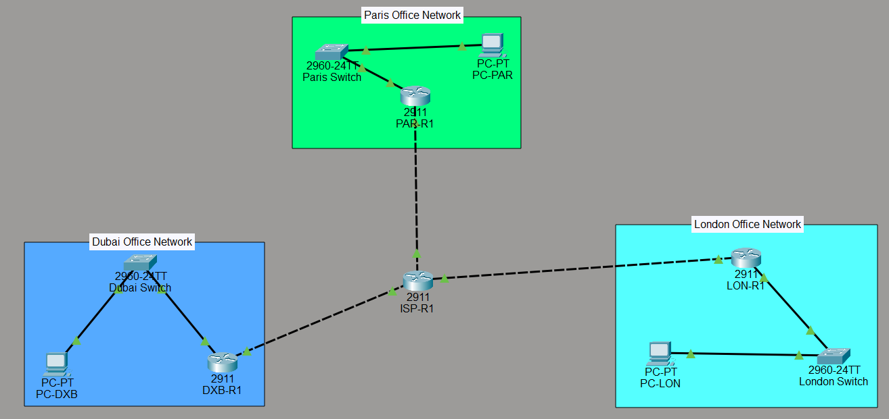
The office LANs are 10.15.1.0/24, 10.25.2.0/24, and 10.35.3.0/24 respectively. The corresponding router LAN addresses are 10.15.1.1, 10.25.2.1, and 10.35.3.1. The PCs use .10 addresses and their local router as the default gateway. The WAN addresses are 198.51.100.50 for Dubai, 203.0.113.60 for London, and 192.0.2.70 for Paris. ISP-R1 uses 198.51.100.1, 203.0.113.1, and 192.0.2.1 on its three WAN-facing interfaces. Static routes were configured so that each office router could reach the other office LANs through the simulated ISP. Additional static routes to the remote WAN subnets were required so that the VPN peer addresses were reachable.
Before VPN configuration, end-to-end pings were used to verify ordinary routing. The tests demonstrated that the routers could route traffic between the three LANs before encryption was introduced.
IPsec configuration
Security features were enabled on the three office routers using the available security technology package. The common IKEv1 policy was:
- crypto isakmp policy 10
- encryption aes 256
- hash sha
- authentication pre-share
- group 5
The crypto isakmp policy command creates the IKE policy. Encryption protects the IKE negotiation, SHA provides hashing, authentication pre-share selects a shared secret for peer authentication, and group 5 selects the Diffie-Hellman key-exchange group.
Each router was then configured with the pre-shared key for both remote peers. Dubai used the London address 203.0.113.60 and Paris address 192.0.2.70. London used Dubai 198.51.100.50 and Paris 192.0.2.70. Paris used Dubai 198.51.100.50 and London 203.0.113.60. Consistent peer addressing and keys were essential because each tunnel requires both endpoints to agree on authentication information.
The IPsec transform set on all three routers was:
- crypto ipsec transform-set VPN-SET esp-aes esp-sha-hmac
This defines ESP with AES encryption and SHA-HMAC integrity protection. Cisco explains that transform sets are used during IPsec security association negotiation to determine how protected data flows are secured.
Crypto ACLs were used to identify interesting traffic. On Dubai, ACL 110 matched 10.15.1.0/24 to 10.25.2.0/24, while ACL 120 matched 10.15.1.0/24 to 10.35.3.0/24. London used ACL 110 for its traffic to Dubai and ACL 120 for traffic to Paris. Paris used ACL 110 for traffic to Dubai and ACL 120 for traffic to London. These were mirror-image definitions at opposite ends of each tunnel.
Crypto maps then linked the ACLs, remote peers, and transform set. Each router used VPN-MAP with sequence 10 for one peer and sequence 20 for the other. For example, the Dubai router associated ACL 110 with peer 203.0.113.60 and ACL 120 with peer 192.0.2.70. The map was applied to GigabitEthernet0/1, the WAN interface. Cisco documentation states that crypto maps bring together the protected traffic definition, remote peer, transform set, and interface application.

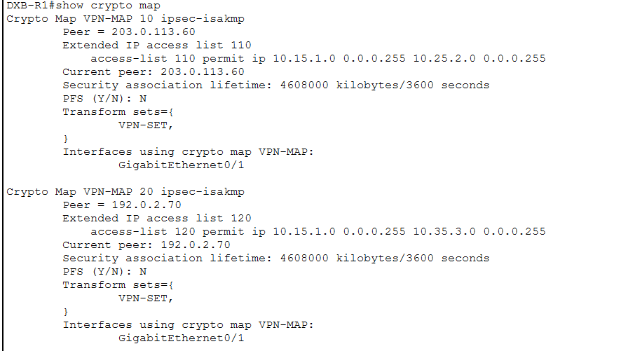
Verification
Verification was performed using show crypto isakmp sa and show crypto ipsec sa. The ISAKMP output on LON-R1 showed both remote peers in QM_IDLE with ACTIVE status. PAR-R1 also showed both peers in QM_IDLE and ACTIVE status. DXB-R1 showed the London peer in QM_IDLE and ACTIVE; the Paris association displayed ACTIVE (deleted) at one point, but the subsequent IPsec counters and successful end-to-end testing demonstrated that Dubai-Paris traffic was being processed by IPsec.
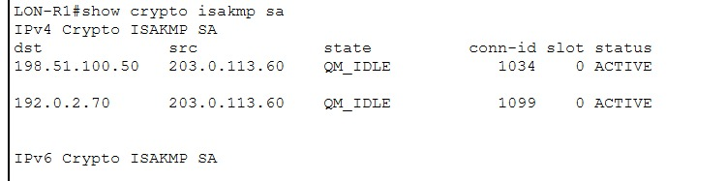
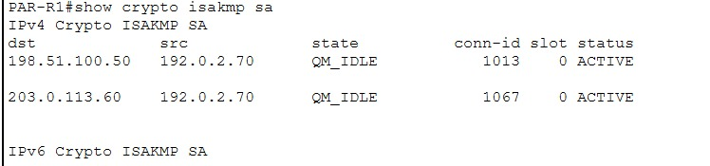
The IPsec statistics provided stronger evidence because they showed actual traffic being encapsulated, encrypted, decapsulated, and decrypted. On DXB-R1, the Dubai-Paris peer reached 11 packets for each of the four counters. On LON-R1, the London-Dubai peer showed 6 encapsulated, 6 encrypted, 7 decapsulated, and 7 decrypted packets, while the London-Paris peer showed 7 in all four counters. On PAR-R1, the Dubai peer showed 11 in all four counters and the London peer showed 7 in all four counters.
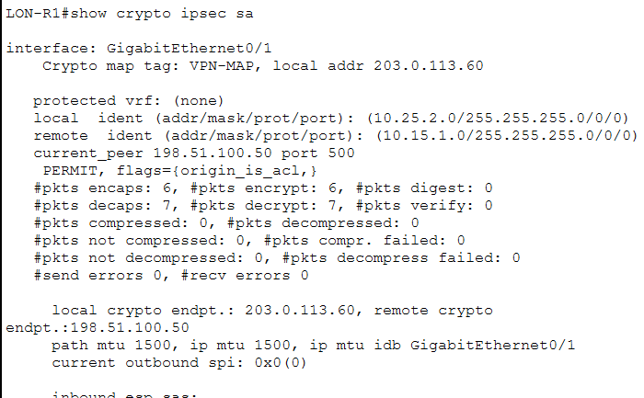
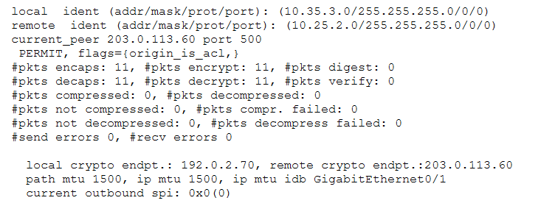
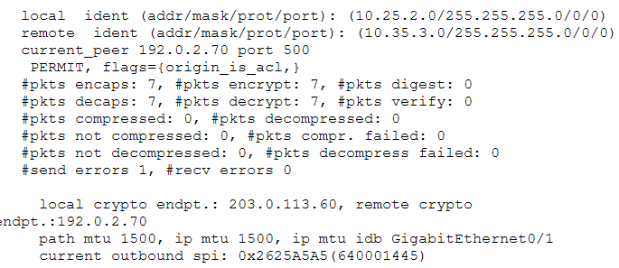
End-to-end testing also succeeded. Dubai-to-London communication reached 100% success. Dubai-to-Paris communication reached 100% success. The first London-to-Paris test had 25% loss, but the repeated test achieved 0% loss after the security association had become established.
Part 3: Testing and Troubleshooting
Testing focused on generating traffic that matched each crypto ACL. A ping from PC-DXB at 10.15.1.10 to PC-LON at 10.25.2.10 generated interesting traffic for the Dubai-London tunnel. A ping from PC-DXB to PC-PAR at 10.35.3.10 tested Dubai-Paris. A ping was sent from PC-LON to PC-PAR to test the London-Paris connection and the responses were successful as IPsec counters increased showing that the traffic was not just being passed through but also it was being handled by IPsec.
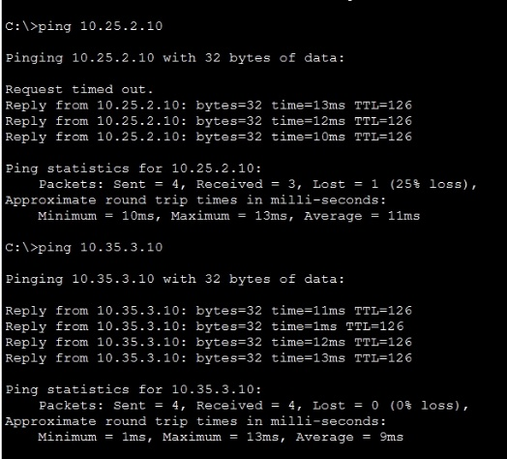
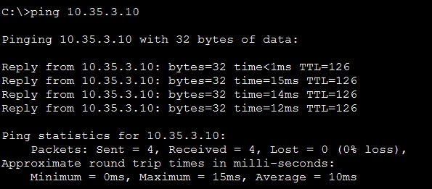

There are a number of helpful lessons that emerged from the troubleshooting process. For a start, more static routes to remote WAN subnets were needed for initial inter-office WAN reachability. Once the routes were added, peer addresses become reachable via ISP-R1. Initially, the tunnel from Dubai was unresponsive on PC-DXB and its ISAKMP state was not immediately stable. A systematic check instead of random changes was performed for configuration. The following were checked and verified: Peer addresses, crypto ACLs, transform sets, crypto maps, interface application, routing, and the security license. Also, some diagnostic clear commands were not accepted by Packet Tracer either, hence they were not relied upon.
Later the Dubai-Paris tunnel started processing traffic, first with IPsec counters, and then it showed 7 and then 11 counters in all four counters of interest. While doing a ping from PC-DXB to PC-PAR was 100% successful. For London-to-Paris it had a 25% loss but the IPsec counters were all set to 3 due to traffic having already been encrypted. The test was repeated, and 0% loss was incurred. This shows that the initial packets can be impacted during the negotiation of IKE and IPsec security associations. The repeated test gave a more accurate assessment of steady connectivity.
Part 4: Reflection and Documentation
This assignment has been helpful to me in understand how routing and VPN security work. I learned that a VPN is not the solution for lack of basic reachability. Additionally, routers have to be configured with routes to remote LANs and to the VPN peer WAN addresses prior to troubleshooting IPsec. This introduced a more well-defined troubleshooting process that is check interfaces and routes, then check IKE, then check IPsec counters, and then check end-to-end traffic.
The most difficult part was the management of the 3 tunnels since each router had 2 peers that were remote, and each peer needed to have matching authentication, ACL, transform-set and crypto-map information to be configured. I discovered that most important is mirror-image crypto ACLs and even if the peer is reachable, a source/destination mismatch can cause unusual traffic to not match the tunnel that was intended.
The Packet Tracer simulation has also given me an understanding of the difference between a configured VPN and an active VPN. Commands such as show crypto map can show configuration of some commands, show crypto isakmp sa can show negotiation of some commands and show crypto ipsec sa can provide evidence of negotiated security associations and actual protected traffic.
I also learned not to rely of unsupported Packet Tracer commands and to use available verification outputs.
Generally, this assignment linked the theoretical concept of networking security and the practical router configuration. I gained experience in working with IKEv1, IPsec ESP, AES, SHA-HMAC, pre-shared authentication, crypto ACLs, crypto maps, static routing and systematic troubleshooting. The fully-mesh end-to-end system gave me a practical example of how geographical separation networks can communicate securely through simulated public infrastructure. I would also look at certificate-based authentication and more robust modern IKE/IPsec profile sets, centralized monitoring, key rotation, redundancy, logging and documented change management processes, in a production environment.
Conclusion
The Horizon Enterprises network was designed and configured in Cisco Packet Tracer successfully to be a full-mesh IPsec VPN between three sites. Basic reachability was set up using static routing, and secure processing of traffic between office networks was provided by IKE and IPsec. All three tunnel pairs were found to have IKE relationships and non-zero IPsec counters. Successful end-to-end tests were conducted between Dubai and London, Dubai and Paris and London and Paris. The troubleshooting process also showed the need for checking routing, reachability of peers, matching of the ACL, security associations and packet counters in a logical order.

References
Barker, E., Dang, Q., Frankel, S., Scarfone, K., & Wouters, P. (2020). Guide to IPSEC VPNs. National Institute of Standards and Technology. https://doi.org/10.6028/nist.sp.800-77r1
Cisco Systems. (2021). Security and VPN Configuration Guide, Cisco IOS XE 17.X: Configuring security for VPNs with IPSec. Cisco. https://www.cisco.com/c/en/us/td/docs/routers/ios/config/17-x/sec-vpn/b-security-vpn/m_sec-cfg-vpn-ipsec-0.html

Academic Integrity Disclaimer
I Alyazai Zayed Rashed Salem Almansoori confirm that this submission is my own academic work and that I have cited sources that I used in preparing this report. I am aware and agree to the university's rules regarding academic honesty and the responsible use of academic resources.

